Saint Charles Borromeo .
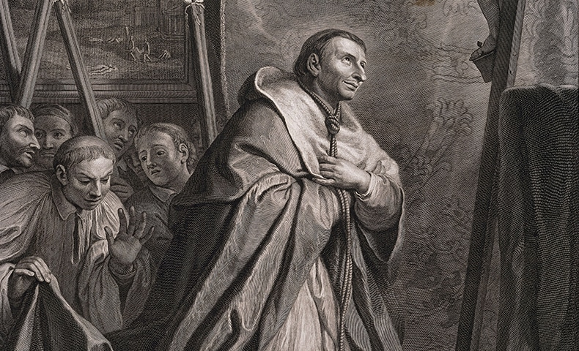

Born: October 2nd 1538
Died: November 3rd 1584
Canonized: November 1st 1610 (Paul V)
Feast: November 4th
Patronage: against ulcers, apple orchards, bishops, catechists, catechumens, colic, intestinal disorder, Lombardy, Italy, Monterey California, cardinals, seminarians, spiritual directors, spiritual leaders, starch makers, stomach diseases, São Carlos city in Brazil (namesake)
History of Relic:
Recipient | Date received | Date Returned | Intention
Joseph Samo

